**SEPTEMBER**

*written by Maurice Sendak*

In September for a while 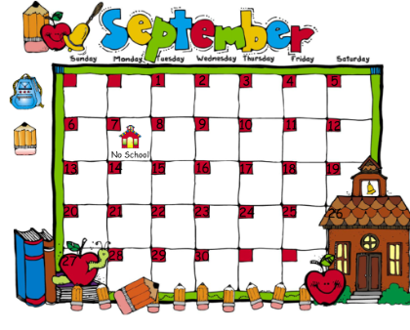

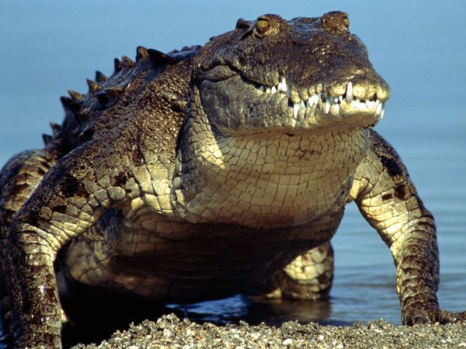 I will ride a crocodile

down the chicken soupy Nile 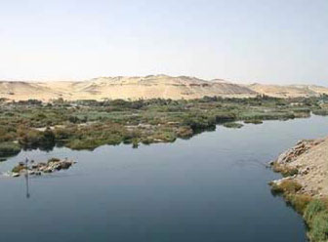

Paddle once, 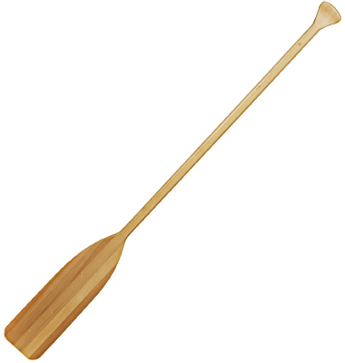, paddle twice ,

Paddle chicken soup with rice. 

 

 

 

